**Name : mohamed yehia kamal ali**

**B.N: 821**

**Date : 30/5/2020**

**Topic:**

**Github link :**

**Github page :**

**Application brief :**

**Big data is a term used to describe a group of big data in terms of size however it grows significantly over time. In short, this data is so large and complex that none of the traditional data management tools can store or process it efficiently.**

**Big data helps organizations create new growth opportunities and completely new categories of companies that allow industry data to be integrated and analyzed. These companies have ample information about products and services, buyers and suppliers, and consumer preferences that can be captured and analyzed.**

**Source code :**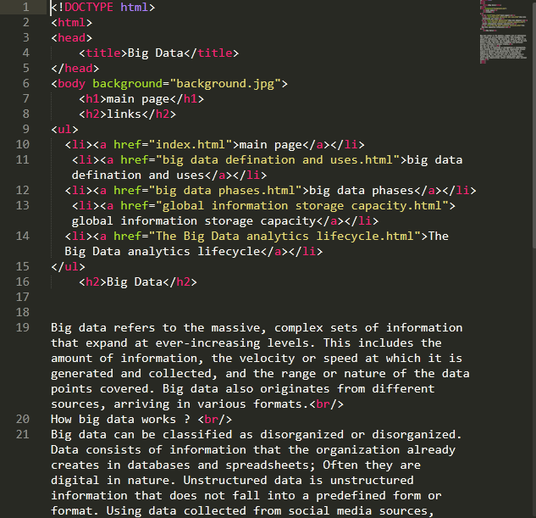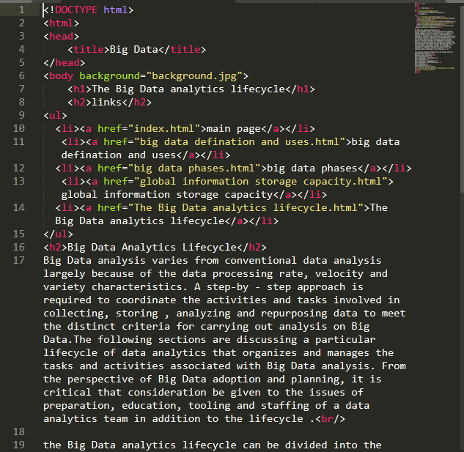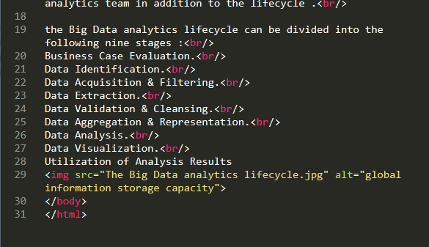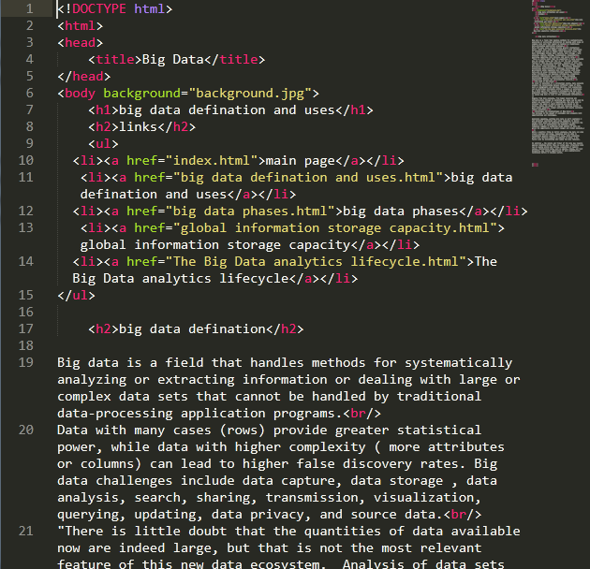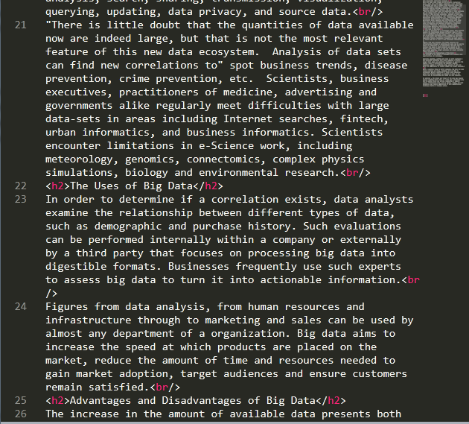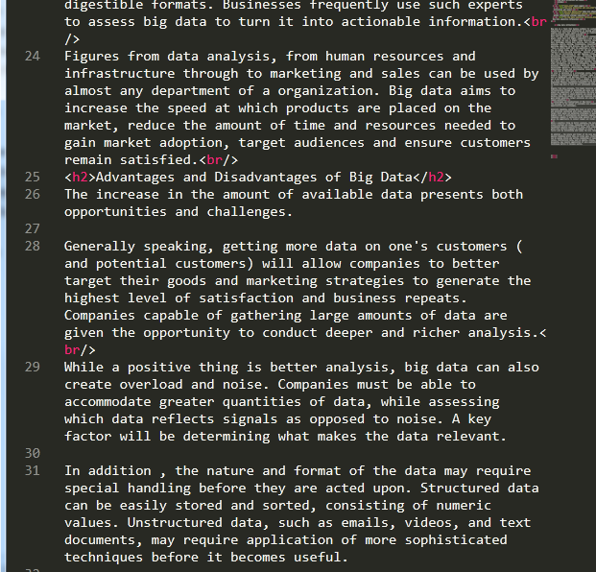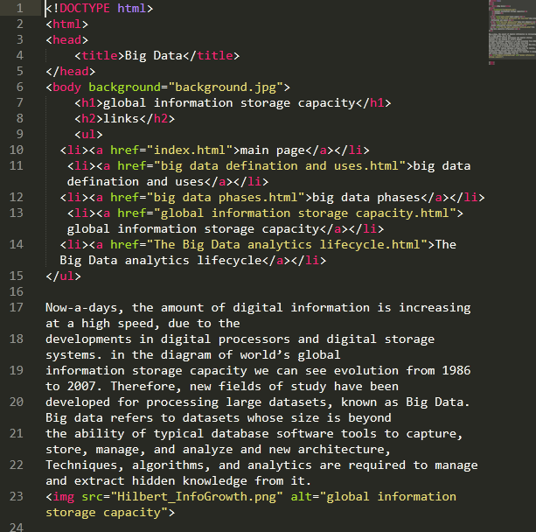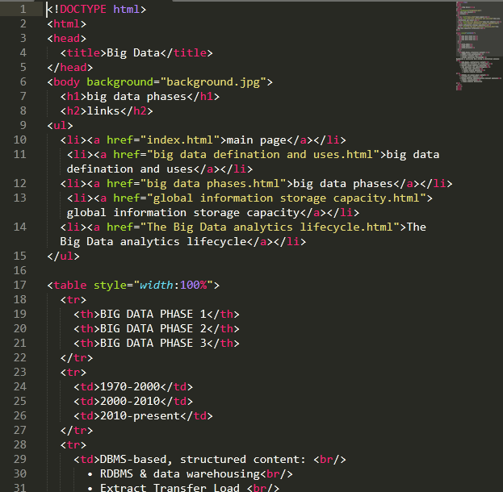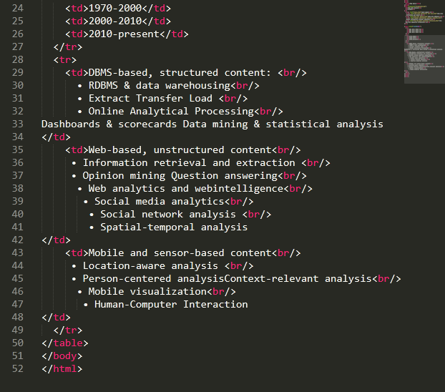

**Screenshots :**

